Mutual information: EURUSD and USDJPY
Method 15 / daily log returns / B=10 equal-frequency bins / Alpari D1 full available history

Study setup
Logical pair: EURUSD , USDJPY
Broker symbols: EURUSD_i , USDJPY_i
Snapshot: 2026-11-03_majors_alpari_D1
Timeframe: D1
Matched return window: 1999-01-05 to 2026-11-02 (UTC bar dates)
Matched return count n: 7200
Dropped unfinished last bar dated 2026-11-03 UTC after a tick-volume check against the prior complete day.
Discretization: B=10 equal-frequency bins per leg
Units: nats (natural log)
Complete matched rows (Excel): EURUSD-USDJPY_MI_D1.xlsx
Complete matched rows (HTML table): EURUSD-USDJPY_MI_D1_data.html

Method carried forward
Mutual information I(X;Y) measures shared information between matched daily log returns of close, ln(close_t / close_t-1), after a fixed discretization. Quotes are not inverted. Each leg is cut into B=10 equal-frequency (decile) bins using that leg's matched-sample quantiles. Discrete MI uses natural log (nats): I = sum p_ab ln(p_ab / (p_a p_b)). Marginal entropies H_x and H_y and normalized MI = I / sqrt(H_x H_y) are stored for comparison. Bin count is not tuned after seeing pair rankings. Same-sample Pearson r is a side check only. This is not causation, lead-lag, or a trading signal.

Results
I(X;Y): 0.091193 nats
Normalized MI: 0.039605
H_x: 2.302573
H_y: 2.302585
Same-sample Pearson r: -0.300952

Conclusion
Over 7200 matched daily rows for EURUSD and USDJPY with B=10 equal-frequency bins, I(X;Y) = 0.091193 nats (normalized MI = 0.0396; H_x=2.3026, H_y=2.3026). Same-sample Pearson r is -0.3010. This does not establish cause, lead-lag, or a lasting trading rule.

Charts
Daily closes

Daily log returns

Joint bin-count heatmap
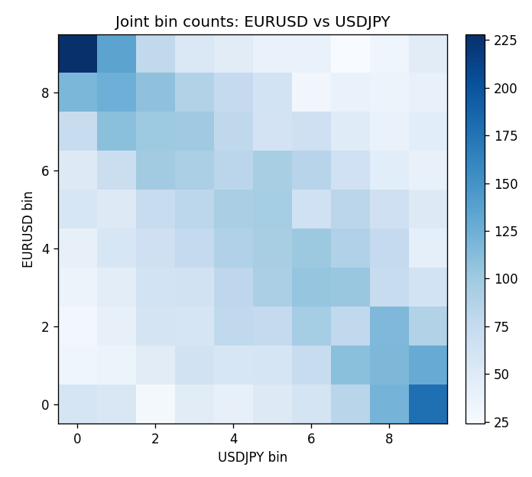

Data report
Every matched row that entered MI is stored in the sibling Excel workbook named EURUSD-USDJPY_MI_D1.xlsx, including bin labels. Embedding all rows as a Word table is impractical; this file holds column summaries and the first and last 15 matched rows.
Columns: time, EURUSD_open, USDJPY_open, EURUSD_high, USDJPY_high, EURUSD_low, USDJPY_low, EURUSD_close, USDJPY_close, EURUSD_tick_volume, USDJPY_tick_volume, EURUSD_spread, USDJPY_spread, EURUSD_real_volume, USDJPY_real_volume, EURUSD_log_return, USDJPY_log_return, EURUSD_bin, USDJPY_bin
Column summaries (matched calculation rows)
column | count | mean | std | min | 25% | 50% | 75% | max
EURUSD_open | 7200 | 1.1812699 | 0.15089907 | 0.8272 | 1.086045 | 1.16609 | 1.2939325 | 1.5995
USDJPY_open | 7200 | 113.80877 | 19.206548 | 75.693 | 104.4225 | 110.983 | 120.69125 | 163.824
EURUSD_high | 7200 | 1.1864006 | 0.15149686 | 0.8326 | 1.0901575 | 1.17121 | 1.2991625 | 1.6038
USDJPY_high | 7200 | 114.3063 | 19.268128 | 76.001 | 104.878 | 111.441 | 121.26 | 163.978
EURUSD_low | 7200 | 1.1762568 | 0.15022122 | 0.8227 | 1.0819775 | 1.162475 | 1.288265 | 1.5865
USDJPY_low | 7200 | 113.28572 | 19.134551 | 75.402 | 103.8875 | 110.53 | 120.17 | 163.628
EURUSD_close | 7200 | 1.1813075 | 0.15087411 | 0.8267 | 1.085995 | 1.16602 | 1.2939425 | 1.5997
USDJPY_close | 7200 | 113.82186 | 19.221964 | 75.811 | 104.4165 | 111.023 | 120.6855 | 163.851
EURUSD_tick_volume | 7200 | 103020.56 | 173417.03 | 218 | 9398.5 | 52714 | 99443.25 | 1471626
USDJPY_tick_volume | 7200 | 106139.77 | 179306.98 | 149 | 9927.5 | 53095 | 92761 | 1803508
EURUSD_spread | 7200 | 19.389444 | 16.57873 | 0 | 8 | 12 | 30 | 50
USDJPY_spread | 7200 | 20.3175 | 17.636173 | 0 | 6 | 11 | 30 | 50
EURUSD_real_volume | 7200 | 4.0252061e+10 | 1.6676396e+11 | 0 | 0 | 0 | 0 | 3.6149665e+12
USDJPY_real_volume | 7200 | 3.4708591e+10 | 1.6077621e+11 | 0 | 0 | 0 | 0 | 3.8834203e+12
EURUSD_log_return | 7200 | -1.012e-05 | 0.00580063 | -0.03123819 | -0.0032472 | 0 | 0.00325137 | 0.03433183
USDJPY_log_return | 7200 | 4.989e-05 | 0.00620383 | -0.03908203 | -0.00319719 | 0.00011638 | 0.00340925 | 0.05184024
EURUSD_bin | 7200 | 4.4988889 | 2.8724806 | 0 | 2 | 4 | 7 | 9
USDJPY_bin | 7200 | 4.5 | 2.8724808 | 0 | 2 | 4.5 | 7 | 9
First 15 matched rows (selected columns)
time | EURUSD_close | USDJPY_close | EURUSD_log_return | USDJPY_log_return | EURUSD_bin | USDJPY_bin
1999-01-05 | 1.1758 | 111.92 | -0.0048360507 | -0.00017868311 | 1 | 4
1999-01-06 | 1.1623 | 112.77 | -0.011547966 | 0.0075660159 | 0 | 9
1999-01-07 | 1.1712 | 111.33 | 0.0076280636 | -0.012851583 | 9 | 0
1999-01-08 | 1.1585 | 110.8 | -0.010902799 | -0.0047719894 | 0 | 1
1999-01-11 | 1.1503 | 109.02 | -0.007103287 | -0.016195423 | 0 | 0
1999-01-12 | 1.1555 | 112.6 | 0.0045103728 | 0.032310364 | 8 | 9
1999-01-13 | 1.1681 | 113.52 | 0.010845346 | 0.0081373171 | 9 | 9
1999-01-14 | 1.1681 | 113.52 | 0 | 0 | 4 | 4
1999-01-15 | 1.1563 | 114.15 | -0.010153245 | 0.0055343401 | 0 | 8
1999-01-18 | 1.1605 | 114.16 | 0.0036256946 | 8.7600193e-05 | 7 | 4
1999-01-19 | 1.1603 | 113.52 | -0.00017235436 | -0.0056219403 | 4 | 1
1999-01-20 | 1.1566 | 112.91 | -0.0031939256 | -0.0053879917 | 2 | 1
1999-01-21 | 1.1601 | 113.87 | 0.0030215416 | 0.0084664056 | 7 | 9
1999-01-22 | 1.1587 | 114.56 | -0.0012075213 | 0.0060412564 | 3 | 8
1999-01-25 | 1.1552 | 113.72 | -0.0030251979 | -0.0073594164 | 2 | 0
Last 15 matched rows (selected columns)
time | EURUSD_close | USDJPY_close | EURUSD_log_return | USDJPY_log_return | EURUSD_bin | USDJPY_bin
2026-10-13 | 1.11965 | 158.305 | 0.0037402957 | -0.0018932826 | 7 | 3
2026-10-14 | 1.11545 | 158.317 | -0.0037582255 | 7.5800166e-05 | 2 | 4
2026-10-15 | 1.12172 | 158.024 | 0.0056053107 | -0.0018524319 | 8 | 3
2026-10-16 | 1.12371 | 157.964 | 0.0017724895 | -0.00037976126 | 6 | 4
2026-10-19 | 1.12086 | 158.517 | -0.0025394633 | 0.0034946841 | 2 | 7
2026-10-20 | 1.12354 | 158.16 | 0.0023881672 | -0.0022546642 | 6 | 3
2026-10-21 | 1.12318 | 158.108 | -0.00032046717 | -0.00032883504 | 4 | 4
2026-10-22 | 1.12139 | 156.755 | -0.0015949606 | -0.0085942669 | 3 | 0
2026-10-23 | 1.11989 | 156.81 | -0.001338521 | 0.00035080446 | 3 | 5
2026-10-26 | 1.11735 | 157.458 | -0.0022706559 | 0.0041238746 | 3 | 7
2026-10-27 | 1.11272 | 157.894 | -0.004152342 | 0.0027651658 | 2 | 7
2026-10-28 | 1.1152 | 157.743 | 0.0022262927 | -0.00095679538 | 6 | 3
2026-10-29 | 1.11772 | 157.683 | 0.0022571351 | -0.00038043789 | 6 | 4
2026-10-30 | 1.11644 | 157.516 | -0.0011458446 | -0.0010596481 | 3 | 3
2026-11-02 | 1.11881 | 157.933 | 0.002120569 | 0.0026438521 | 6 | 7

